ASSIGNMENT # 2-1 Due on 9/12/19 Student # …………… Name ………………………….

**STATICS** ***UDM ENGR 3120*** - ***BUCT MEC 1701-1703*** ***CHAPTER 3 – Rigid Bodies*** Student Name……………….........

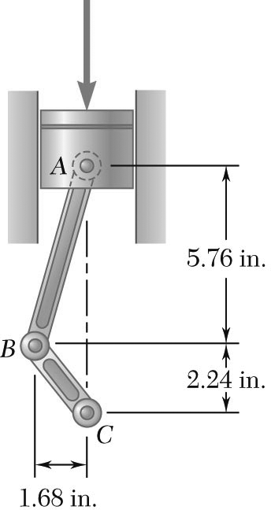

It is known that the connecting rod *AB* exerts on the crank *BC* a 500-lb force directed down and to the left along the centerline of *AB*.

Determine the moment of the force about *C*.